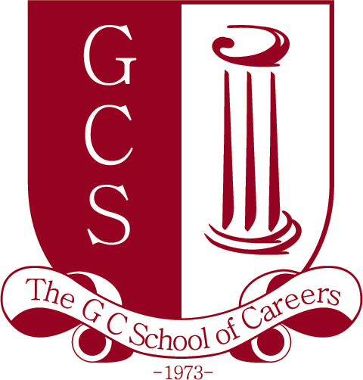Partner search from Cyprus
Programme: | Lifelong Learning Programme - Comenius Multilateral Partnership
Deadline: | February 2013
Contact person: | Mr. Charalambos Toumazou  Function: Project co-ordinator.  Address: 96 Stadiou Str.  2057 Nicosia  Cyprus  E-mail: chtoumazou@gcsc.ac.cy  Cell: 00 357 97 660562
Organisation: | About the school: The GC School of Careers is a private English speaking secondary school located near the centre of Nicosia, Cyprus and is part of a broader family of educational institutions all under the same name. The school has currently 716 students and covers years 7 to 13 (ages 12-18). The School Management’s primary goal is to give all students the opportunity to acquire a solid secondary education and to enable them to develop intellectually and culturally. The entire programme aims at encouraging and guiding students to excel academically, develop their critical, analytical and transferable skills, and become all-round personalities characterized by self-confidence and broad-mindedness.  Our teaching staff (80 strong) is comprised of a rather young and dynamic group of educators who are committed and willing participants in a plethora of extracurricular activities which benefit their students.  Our school has successfully coordinated and participated in Comenius projects before and we are looking forward to another opportunity to coordinate.  For further information about our school please visit our website: www.gcsc.ac.cy
Project idea: | The aim of the project is to develop critical literacy through the use of alternative methods of disseminating information and assessing academic performance.  In order to achieve the aim of the project we would like to experiment with at least some of the following:  - The use of poetry, theatre plays, short films, paintings etc.  - Building board games, models, creating interactive websites etc.  Our working title is:  Critical literacy as a means of developing a more aware, tolerant and accepting European identity/citizen. (Please note that this is a working title that could be modified to become more inclusive should any of our partners request it so.)  If you have any questions about this project please do not hesitate to contact.
Partners searched: | We are seeking partners from all participating countries. We would like this to be a multilateral project so the more the better.
Key words: | Critical thinking, Critical literacy, European identity, Tolerance, Acceptance, Awareness
Project period: | September 2013- June 2015 (Deadline for Comenius Partnership is on the 21st of February 2013)

