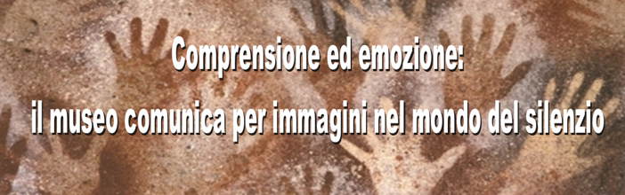

Understanding and emotion: the museums “speak” through images
in the world of silence.

Coordinator: “ Heritage Experience” Cultural Association
The Mission of the Association is to promote and preserve the culture, approaching different public to material and immaterial heritage.
Members of the proponent group: The Office for Cultural Services and Facilities of Regione Lazio
(http://www.culturalazio.it/luoghicultura/musei); Ministry of Art and Culture of Italy (Soprintendenza per i Beni Archeologici dell’Etruria Meridionale http://etruriameridionale.beniculturali.it ; Soprintendenza per i Beni Archeologici del Lazio http://www.archeolz.arti.beniculturali.it) ; ICOM Italia, Accessibility Commission.

This project aims at making easier to the deaf people the approach to the museums and the understanding of their content through the visual language, which allows the deaf person to feel as an equal of an hearing person at least while enjoying the images. In particular, the archaeological exhibitions often don’t take in account that using specialized terms and complicated texts on the educational panels doesn’t make the museum warmly welcome the ordinary public. This is particularly pertinent when we deal with people who are not used to do a lot of reading and often have a poor vocabulary, as the deaf people frequently have.
The idea became consistent after an experiment conducted in the Etruscan National Museum of Villa Giulia in Rome on the 20th Oct. 2012. In that occasion, the short film “Hands to touch, to work, to transform the world” promoted and financed by the Regione Lazio, produced by the Museum of Valentano (http://www.regione.lazio.it/sistemmusei/proust/argomento.php?vms=167) was shown to a group of deaf people who have been asked for an opinion. The way they positively reacted and the following discussion have stimulated our group to try to develop the subject and carry on the experiment to “enter” the world of silence.
The deaf people lack a “radar”, a sound reference that help them to be placed in space and environment, they often miss the story telling of childhood about the past. Therefore, they might need more than others the awareness of their roots. Archaeology might have the ideal function of reconstruct something important and could maybe stimulate them to reflect also about their personal story in a different way.

The guidelines of the project at the moment are supposed to be the following:
- The working team will include museum professionals (archaeologists, directors, education officers and visitor assistants), deaf people, social workers and educators in the field of disabilities, professionals of visual language.
- The discussion and the experiments will be carried on WITH the deaf people as teachers, and not just FOR them. We will try to consider people of different age and cultural level, both speaking and signing.
- Since we deal with suffering people, often excluded and isolated from the daily communication, we would make the approach to the museums an exciting and touching experience, as it enlarges the knowledge of the world, stimulates thinking and establishes important connections with past and future. We would mainly use the sense of seeing, which is often particularly sharp for the deaf people who don’t have the sense of hearing.
- We will try new methods to “enter” the world of silence, for instance work on making someway perceivable the background sounds of a video.
- A list of key words introducing Archaeology will be defined and explained through images.

The archaeological museums of the net of Regione Lazio, not including the big museums of Rome, the will be involved in the project (http://www.culturalazio.it/sistemmusei/proust/argomento.php?vms=150 ). Such museums, belonging to towns of small-medium size, are usually strongly connected to the community and the territory and might show a true and genuine expression of solidarity while dealing with disabilities.
The new skills acquired and the results obtained will be widely spread through the web site www.culturalazio.it and within the net of the archaeological museums of the Regione Lazio (Sistema Museale Proust); a final meeting is also planned.

Contacts

Heritage Experience
Miriam Mandosi miriam.mandosi@gmail.com
+39 3497803441

